Madrid (Spain)

Hi!
Welcome to my brief portfolio.

After that, feel free to contact me.

Thanks for your time.

So, about your suggestions… here my answers go!

…this page intentionally left blank (more or less)…

1. - “Description of my tasks of my practical work experience and final thesis”

About final thesis:
“Design and Development of an Electronic Interface for Magnetorheological Actuators”.

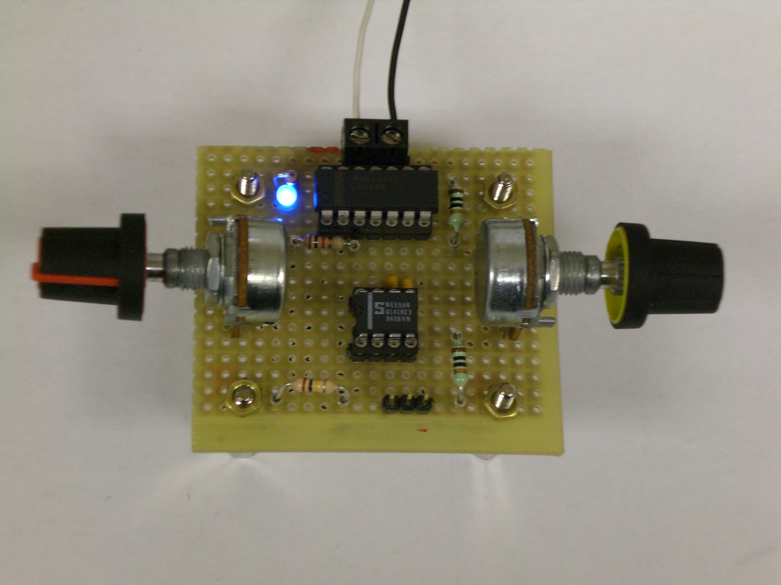 | 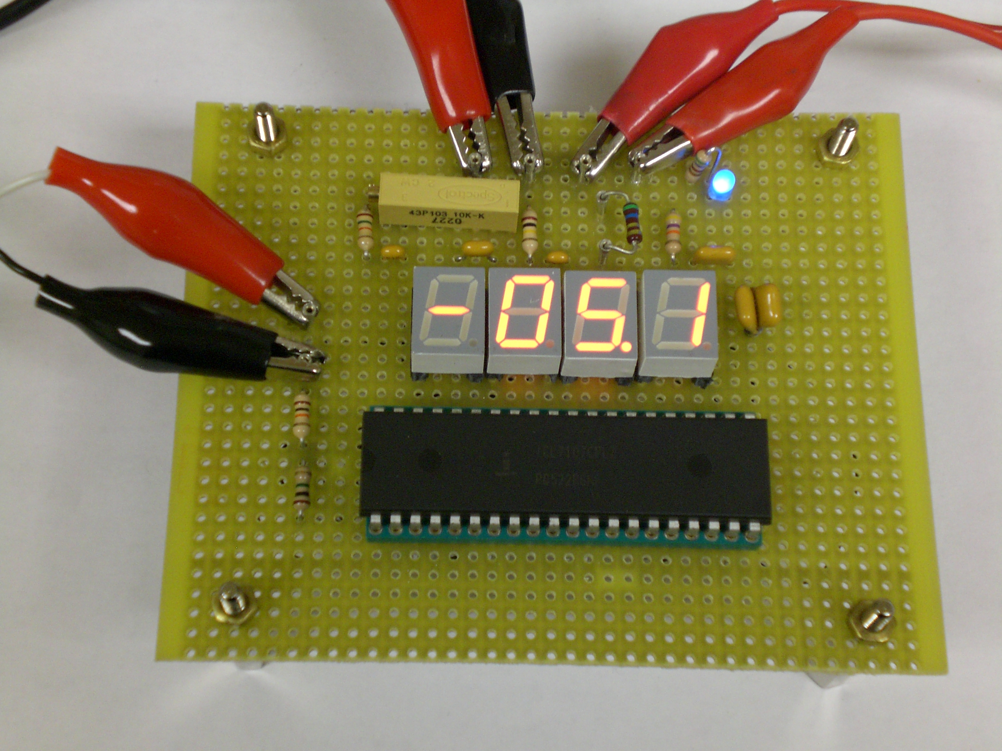
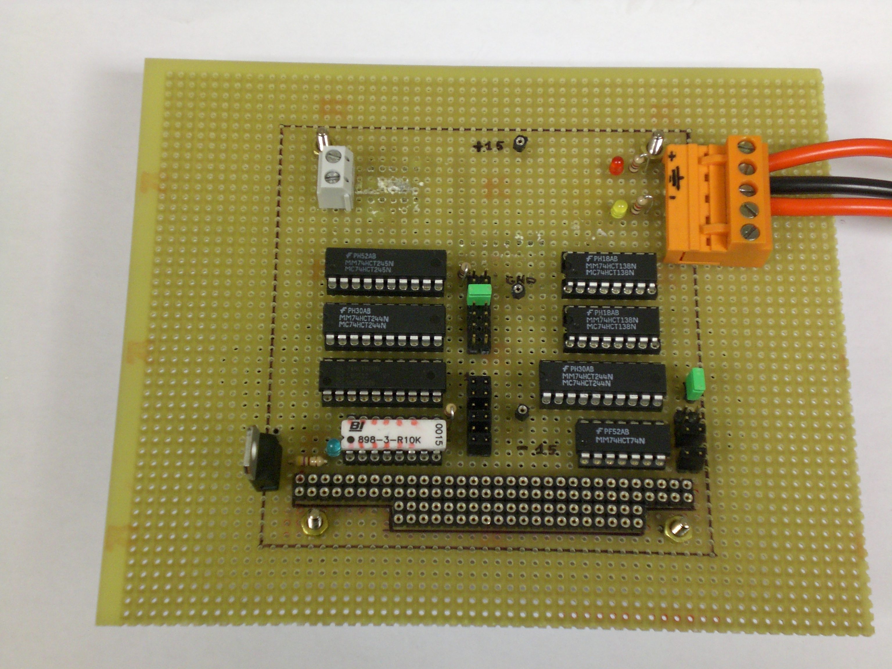 | 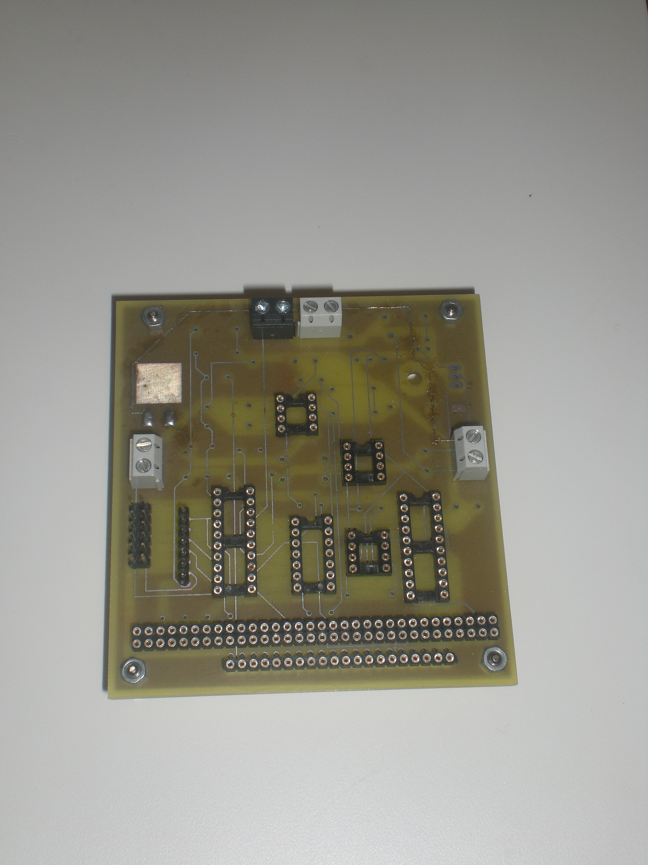

■ Modified PWM by freq. and duty cycle
■ Voltimeter/Amperimeter
■ Prototype of PC104 board by wire wrapping
■ PC104 embedded board - first PCB’s -.

My job was focused to build an interface for this kind of actuators, commonly implemented in Industrial Environment.
■ Mechanical Engineering
[Ex: bumpers of Hummer, from US Army]

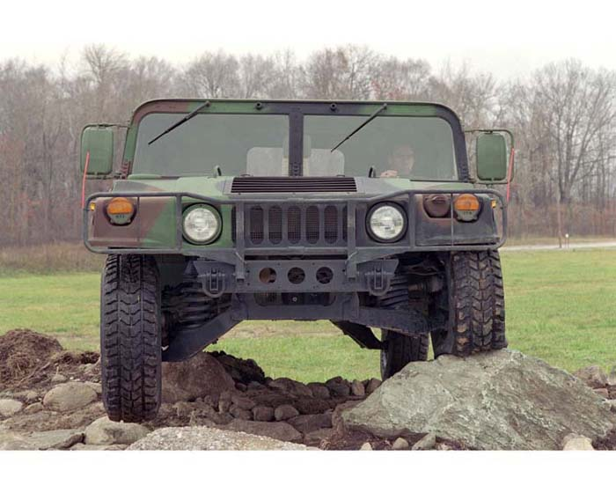

■ Civil Engineering
[Ex: Bridges with protection against Earthquakes]

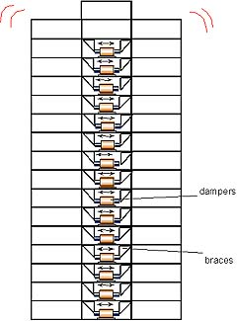 | 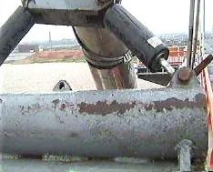

■ Biomedicine / Bioengineering
[Ex: Above-the-Knee (AK) Prosthetic]

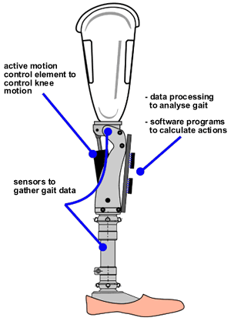

■ Robotics
[Ex: biped robots]

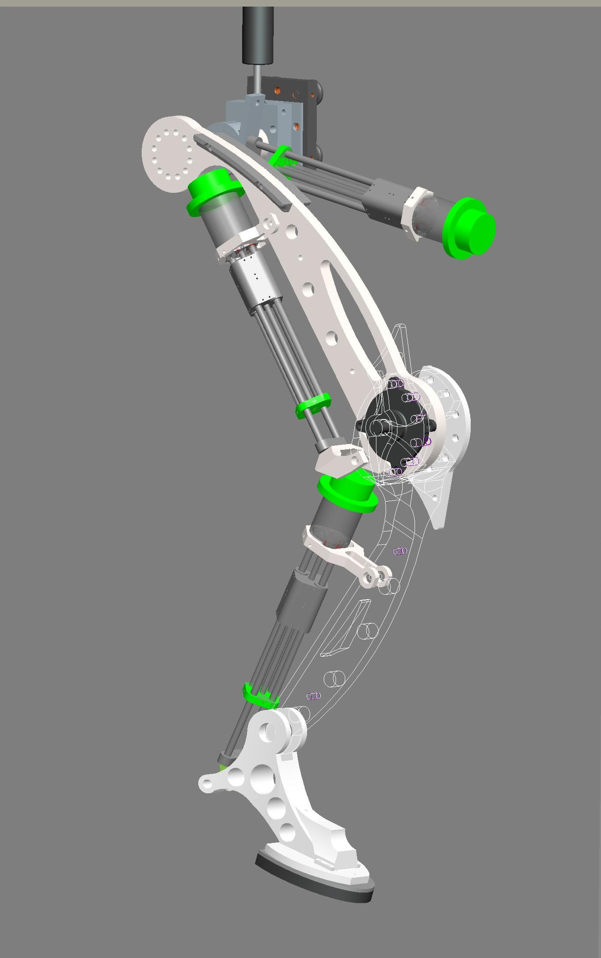

■ Aerospacial / Automotive Engineering
[Ex: BMW vehicles]

■ Trucks
[Ex: more comfortable seats for the driver]

Etc.
About practical work experience:

■ Intern with ROBERT BOSCH S.A. Madrid. Spain. [1998-1999]
[Ex: Instrumentation Frames for Volkswagen Golf]

My job was focused to the Administration and Control of the Instrumentation Frames for VW vehicles, using the SMT technology of the Assembly Chain.

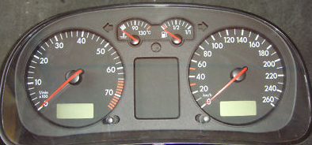

■ Driver and Responsible of all kind of vehicles of the subway. METRO de Madrid S.A. Madrid. Spain. [From 2004-present]
[Ex: High Speed Trains]

My job was like Driver and Responsible of High Speed Trains.

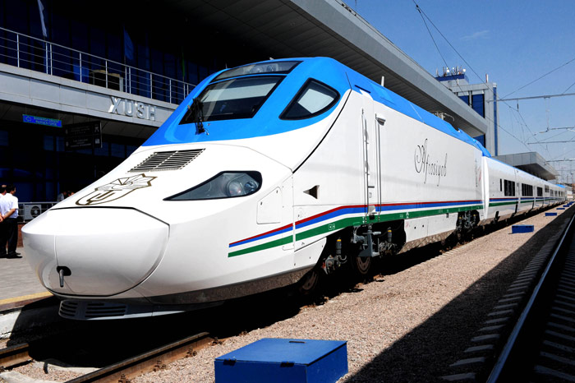

■ Continuously I design new circuits, new micro-robots, etc. I teach for Workshops on Robotics to generic people, teenagers, Colleges, etc.

My hobbies are ROBOTICS, AUTOMATIZATION, ELECTRONICS, MECHATRONICS…

Examples of my work in last months:

■ Robot using ROS and Ubuntu (I am a new worker with both) designed in collaboration with my group for The Field Robot Event [ www.fieldrobot.nl ]
Homemade Dicycle + HOKUYO Laser + ROS + Ubuntu… pid + encoder! Awesome!

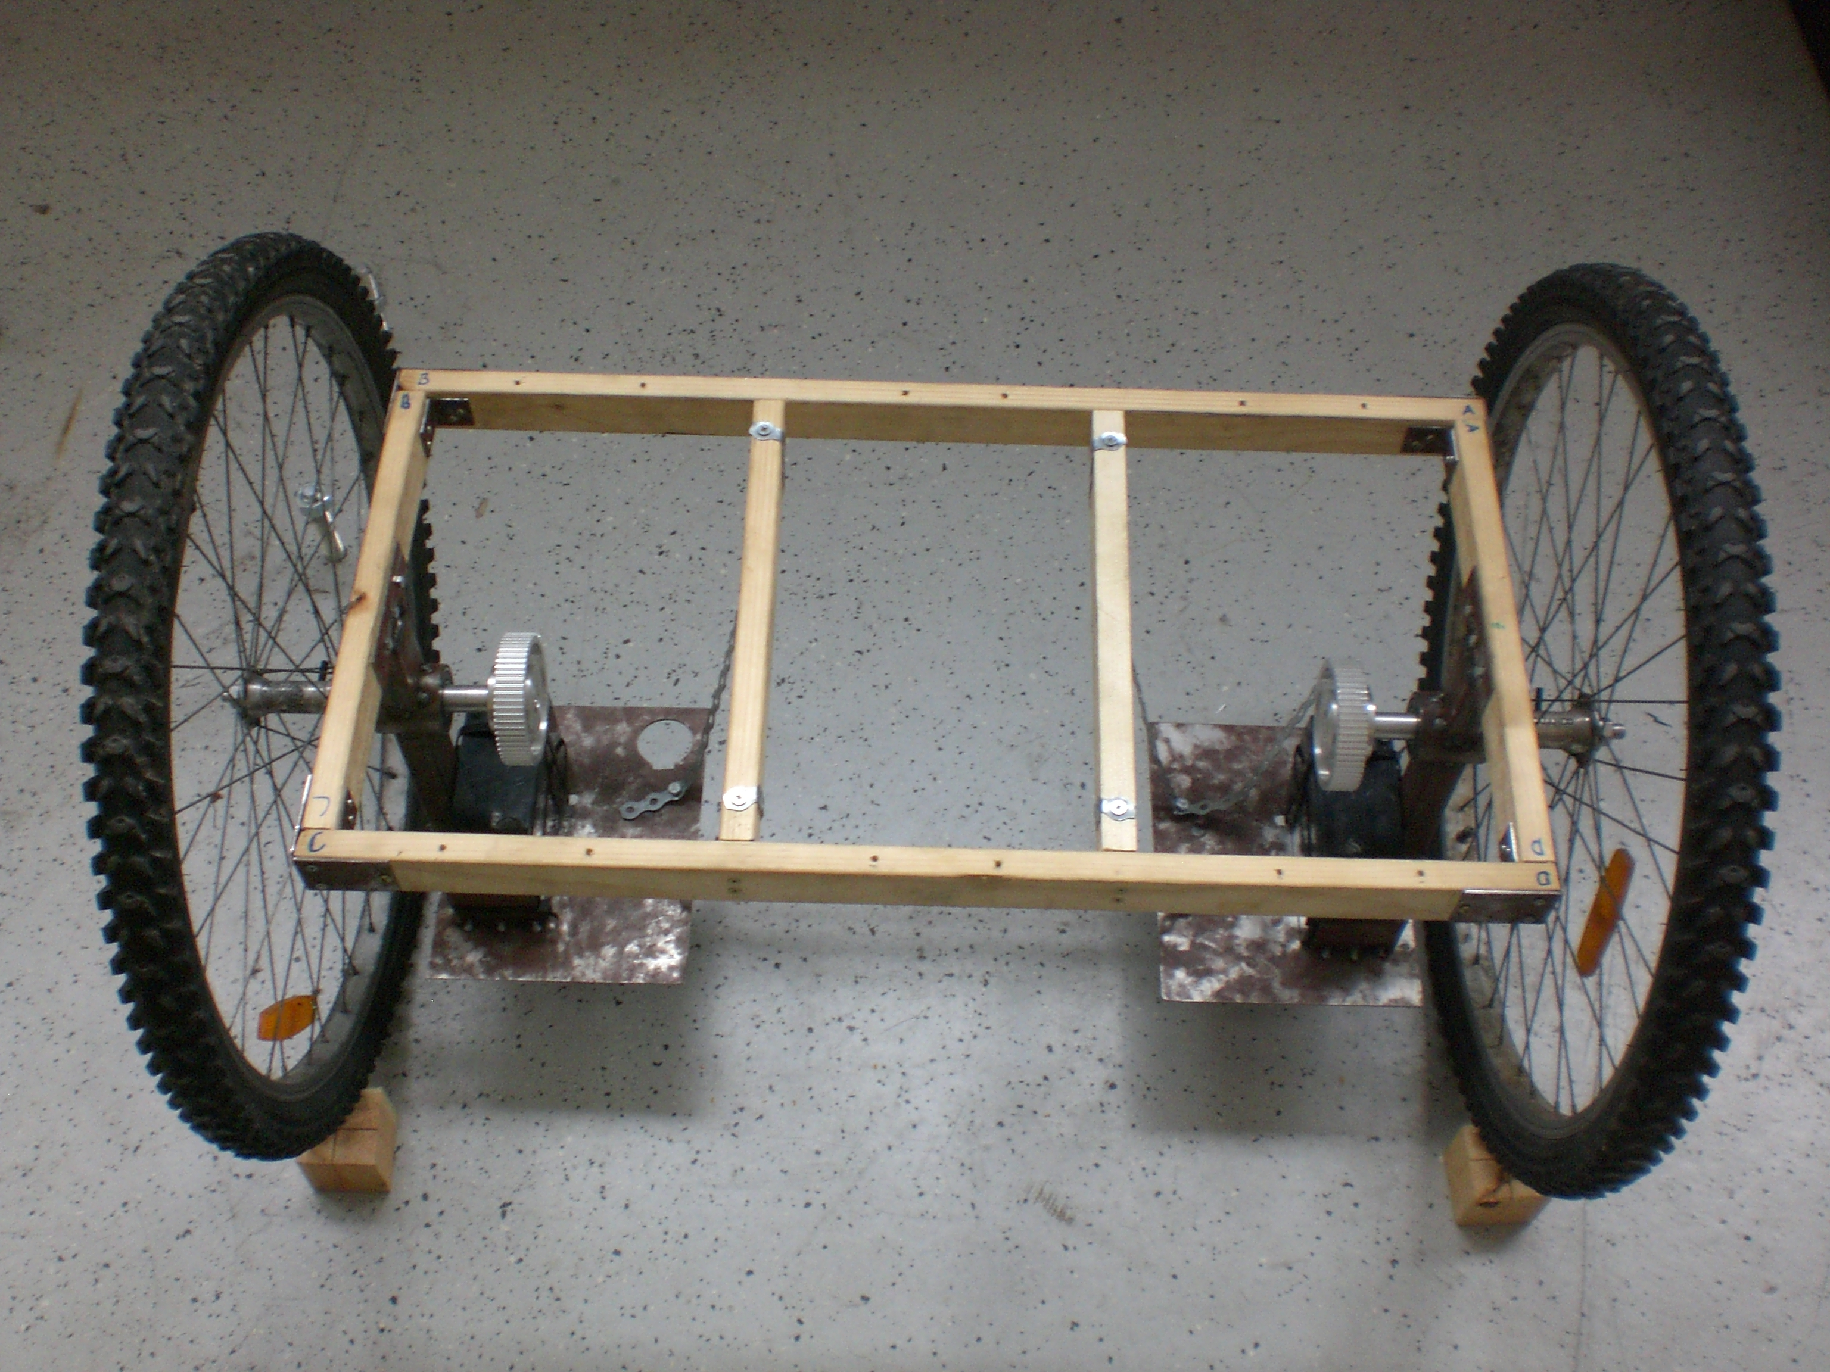 | 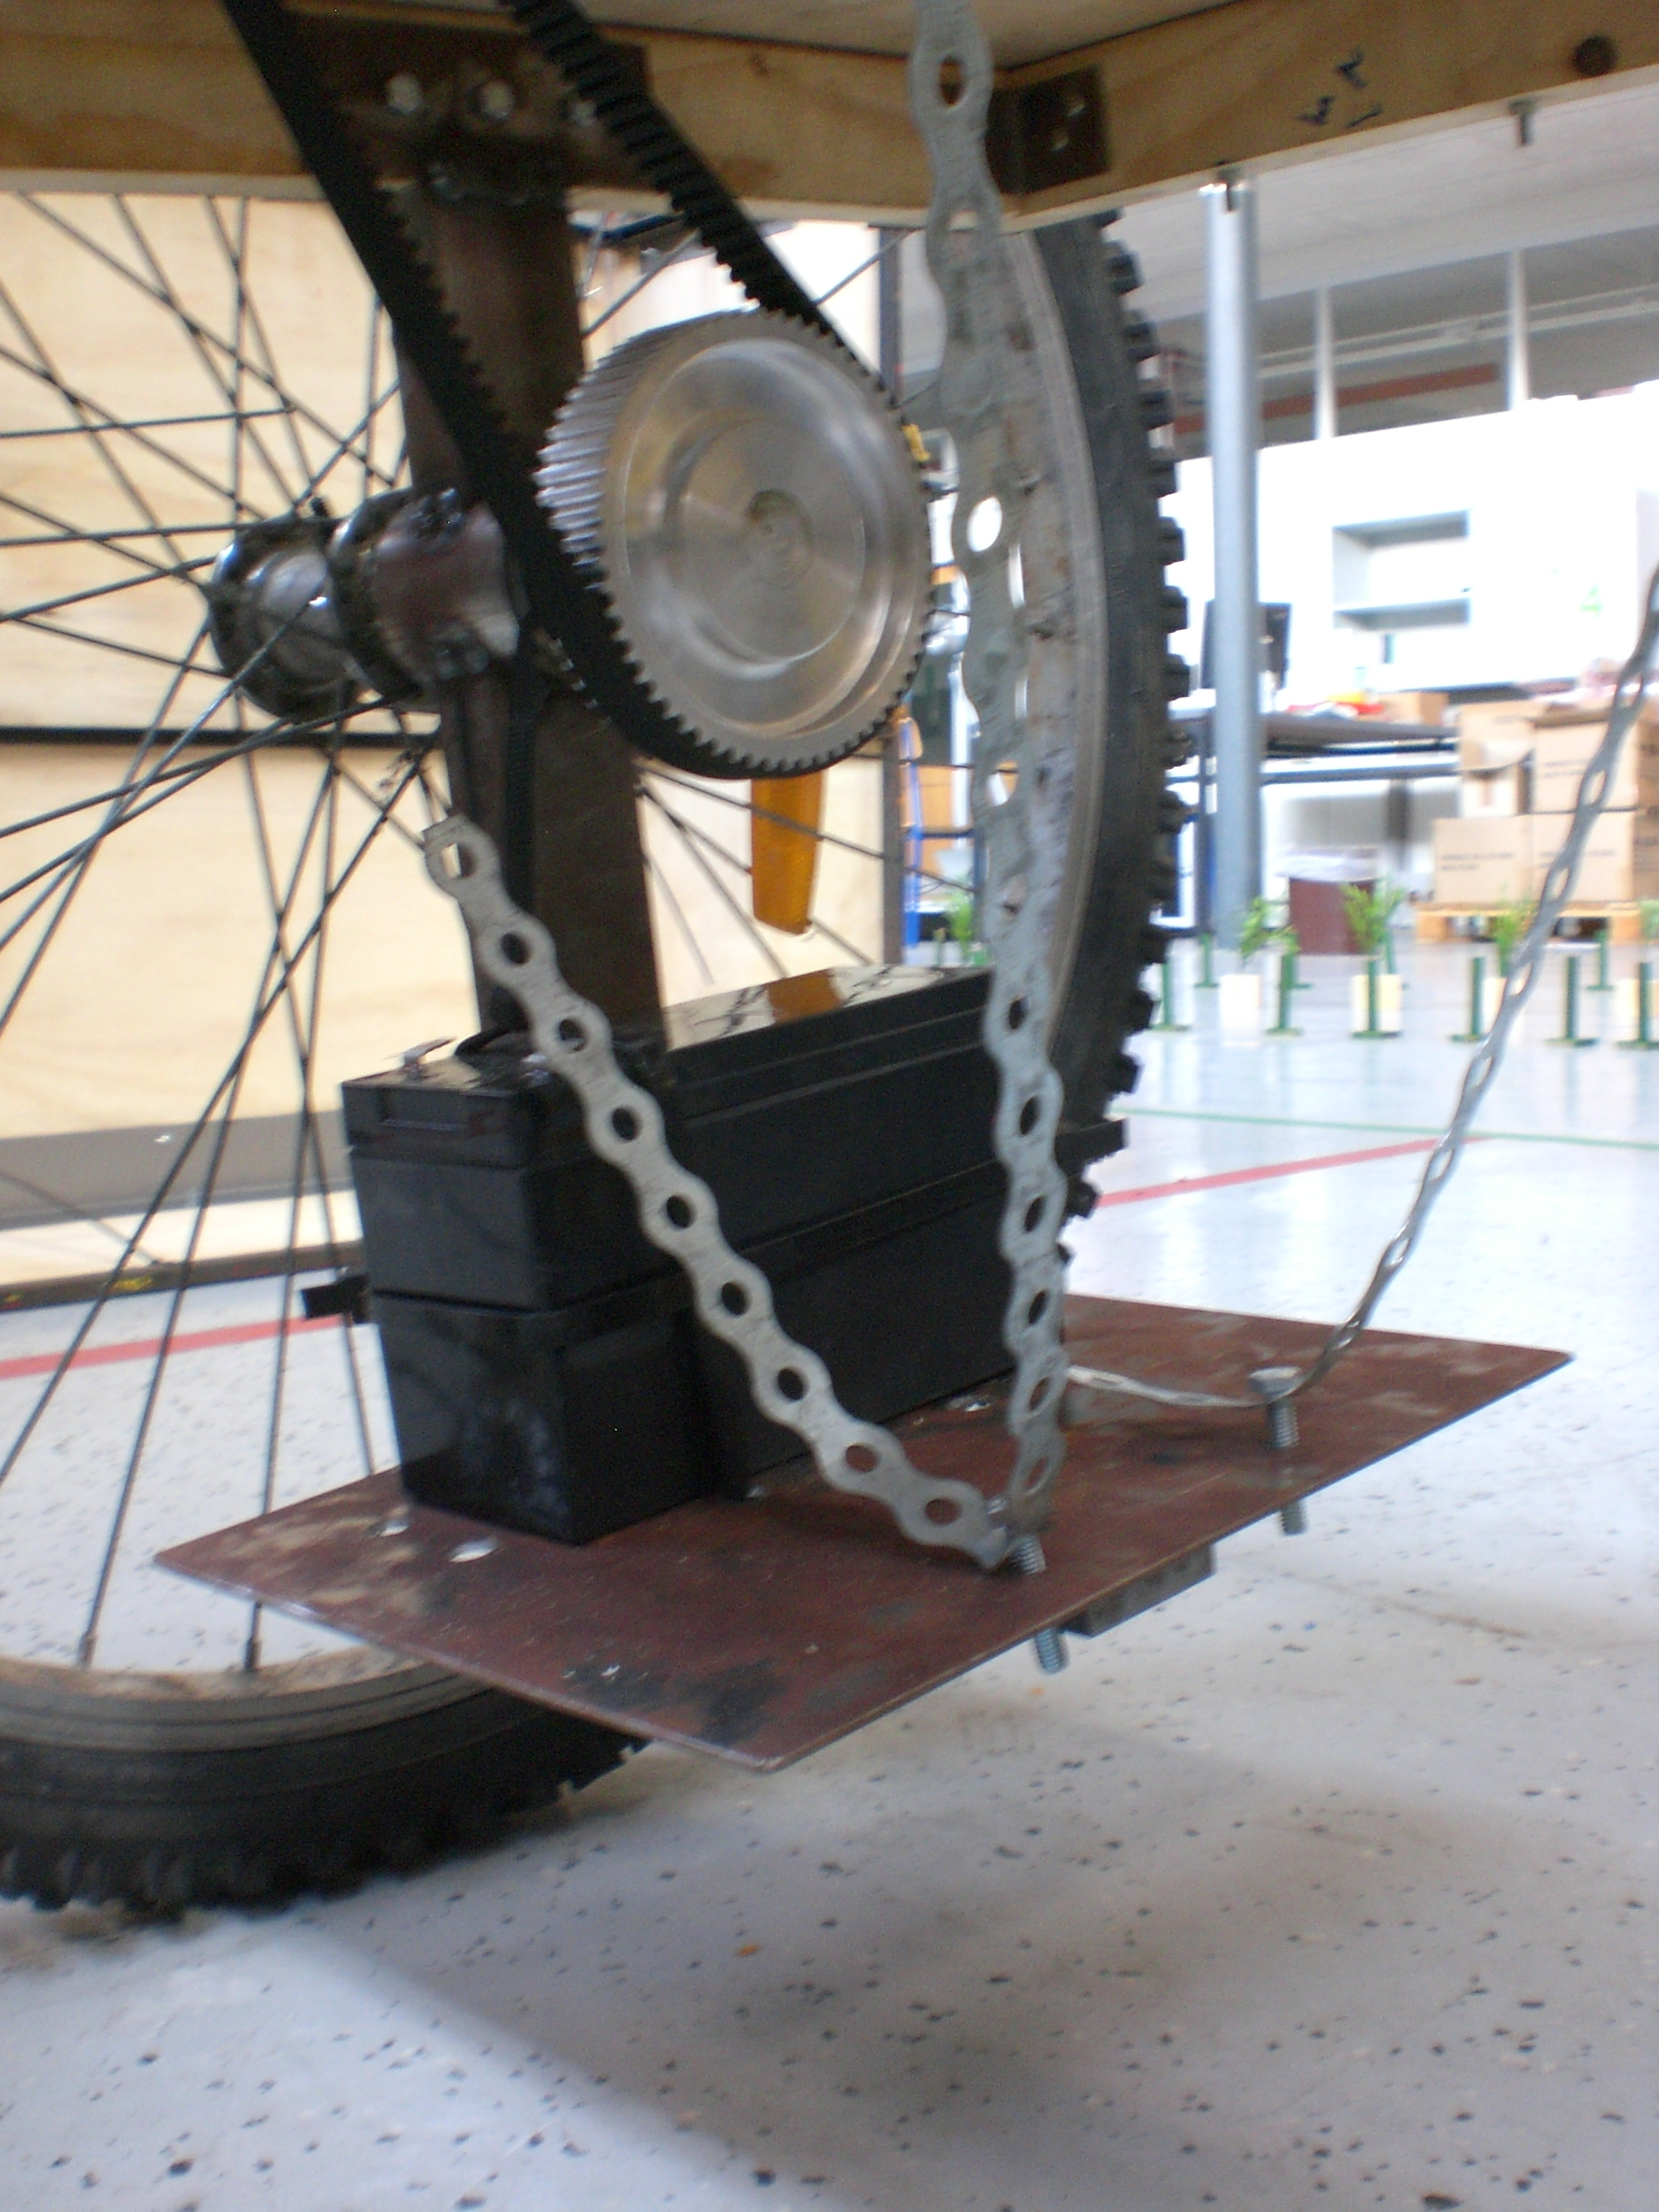 | 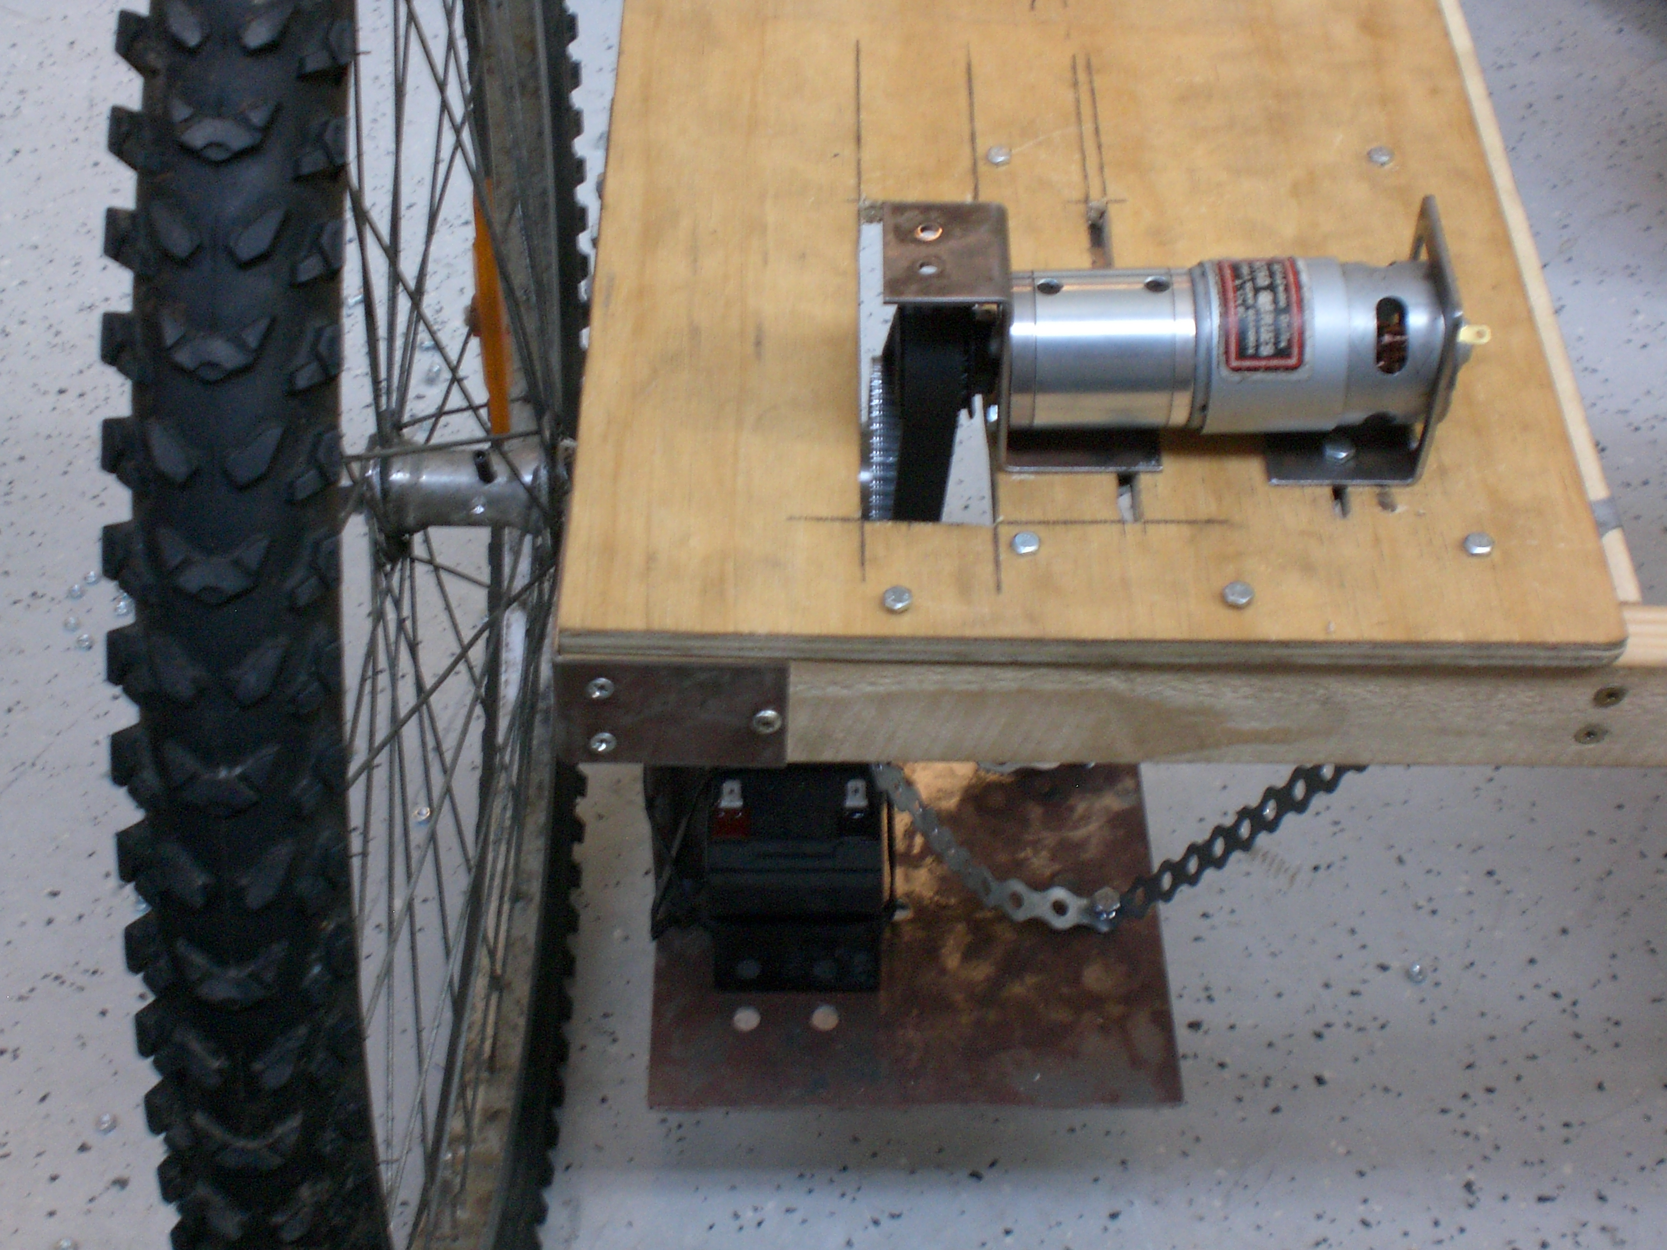
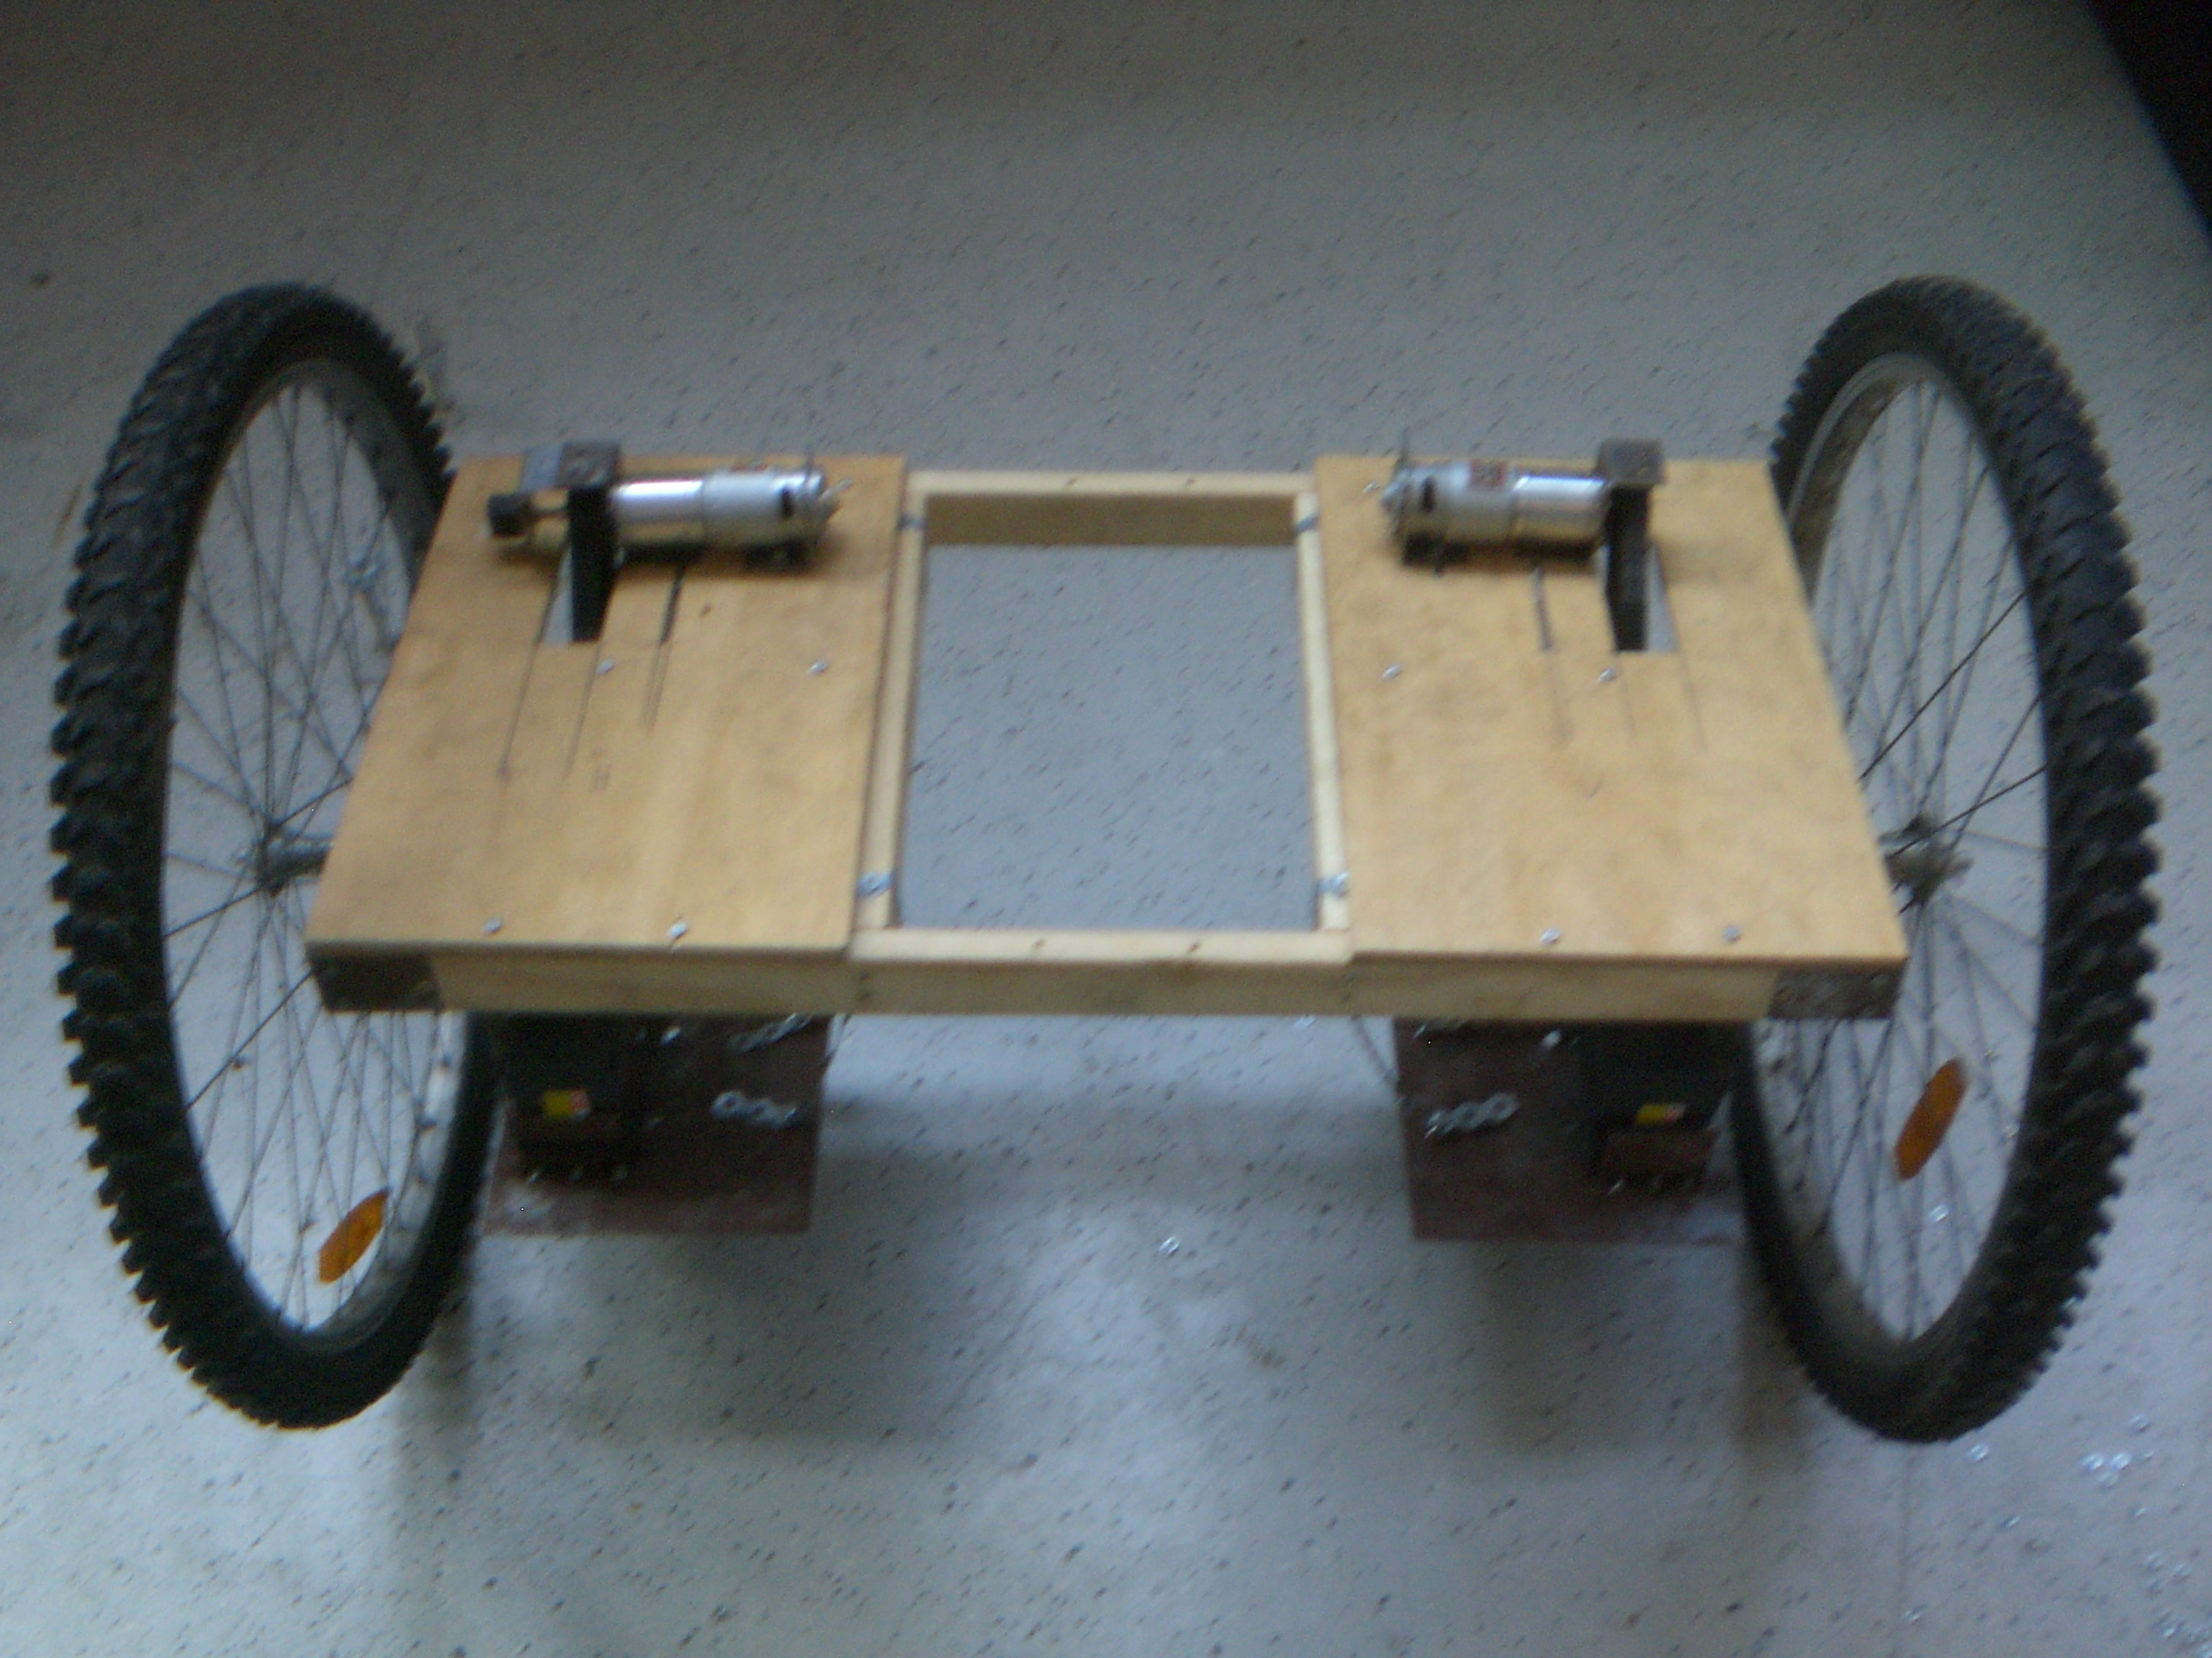 | 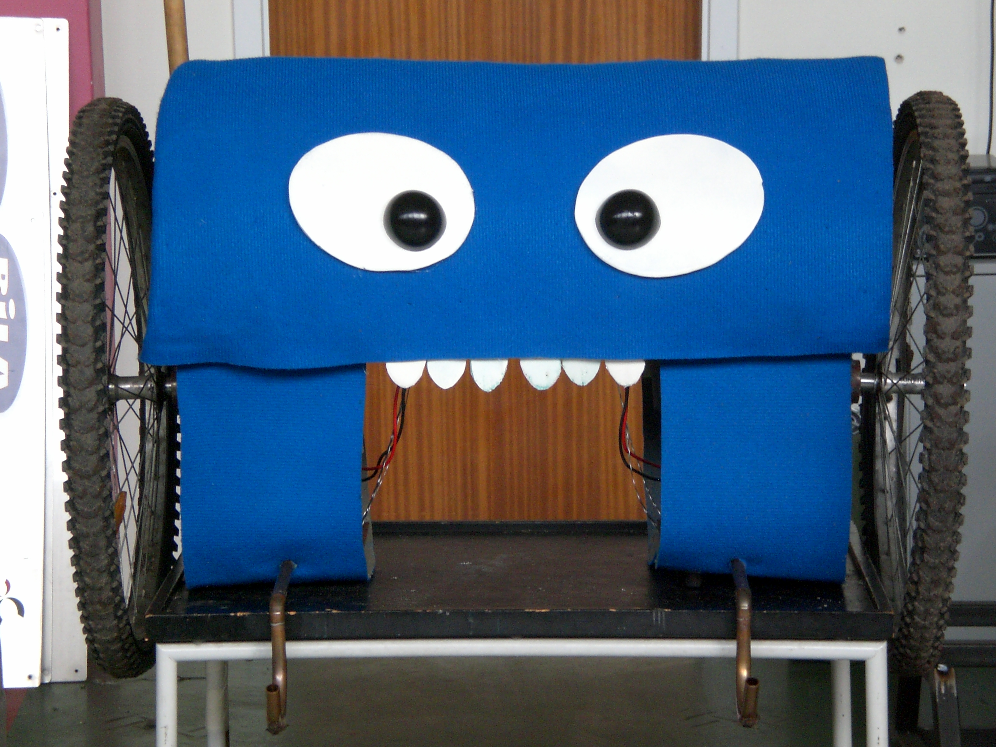 | 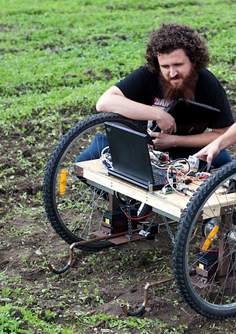

■ My particular platform for R&D and C# application.

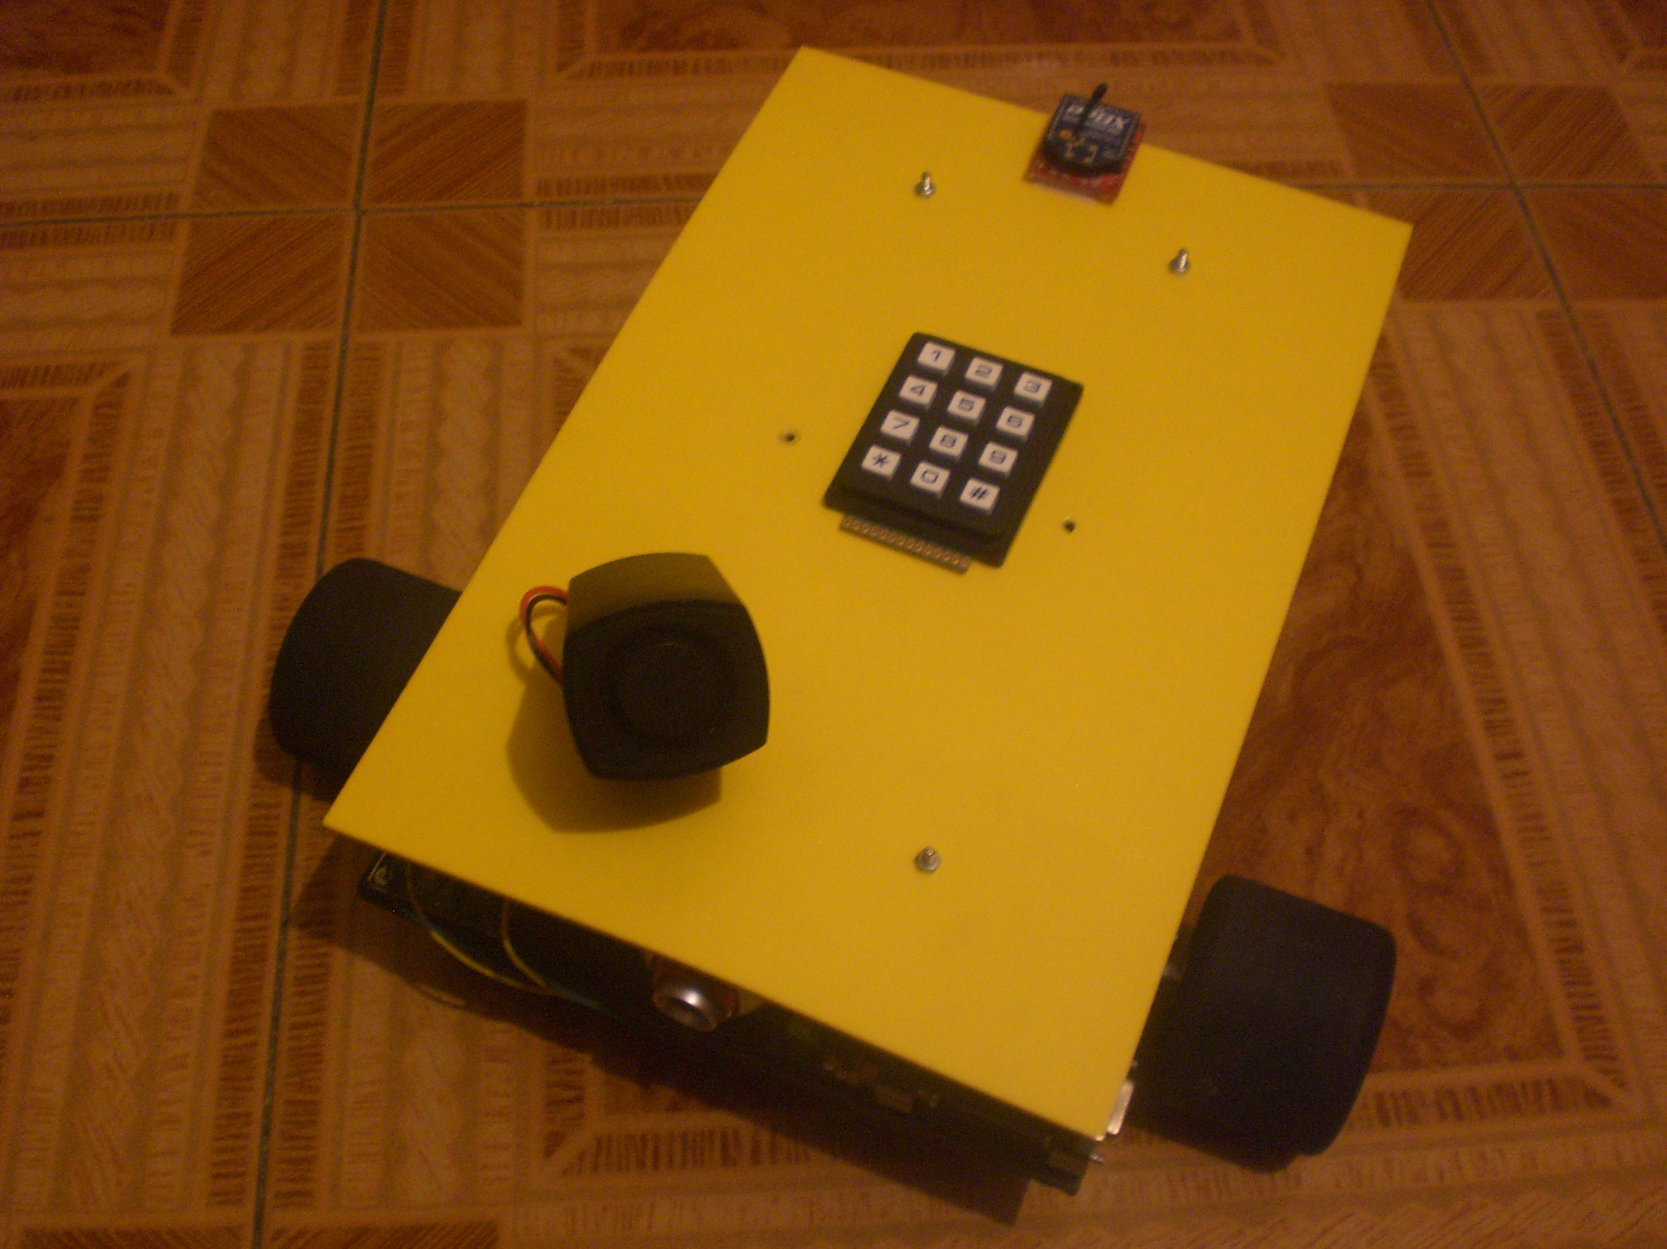 | 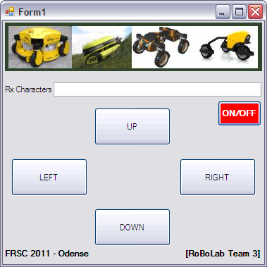

■ Design small development boards (available online!) for robotic events around the world (thanks to my collaborators: www.sparkfun and www.innovati.com.tw )

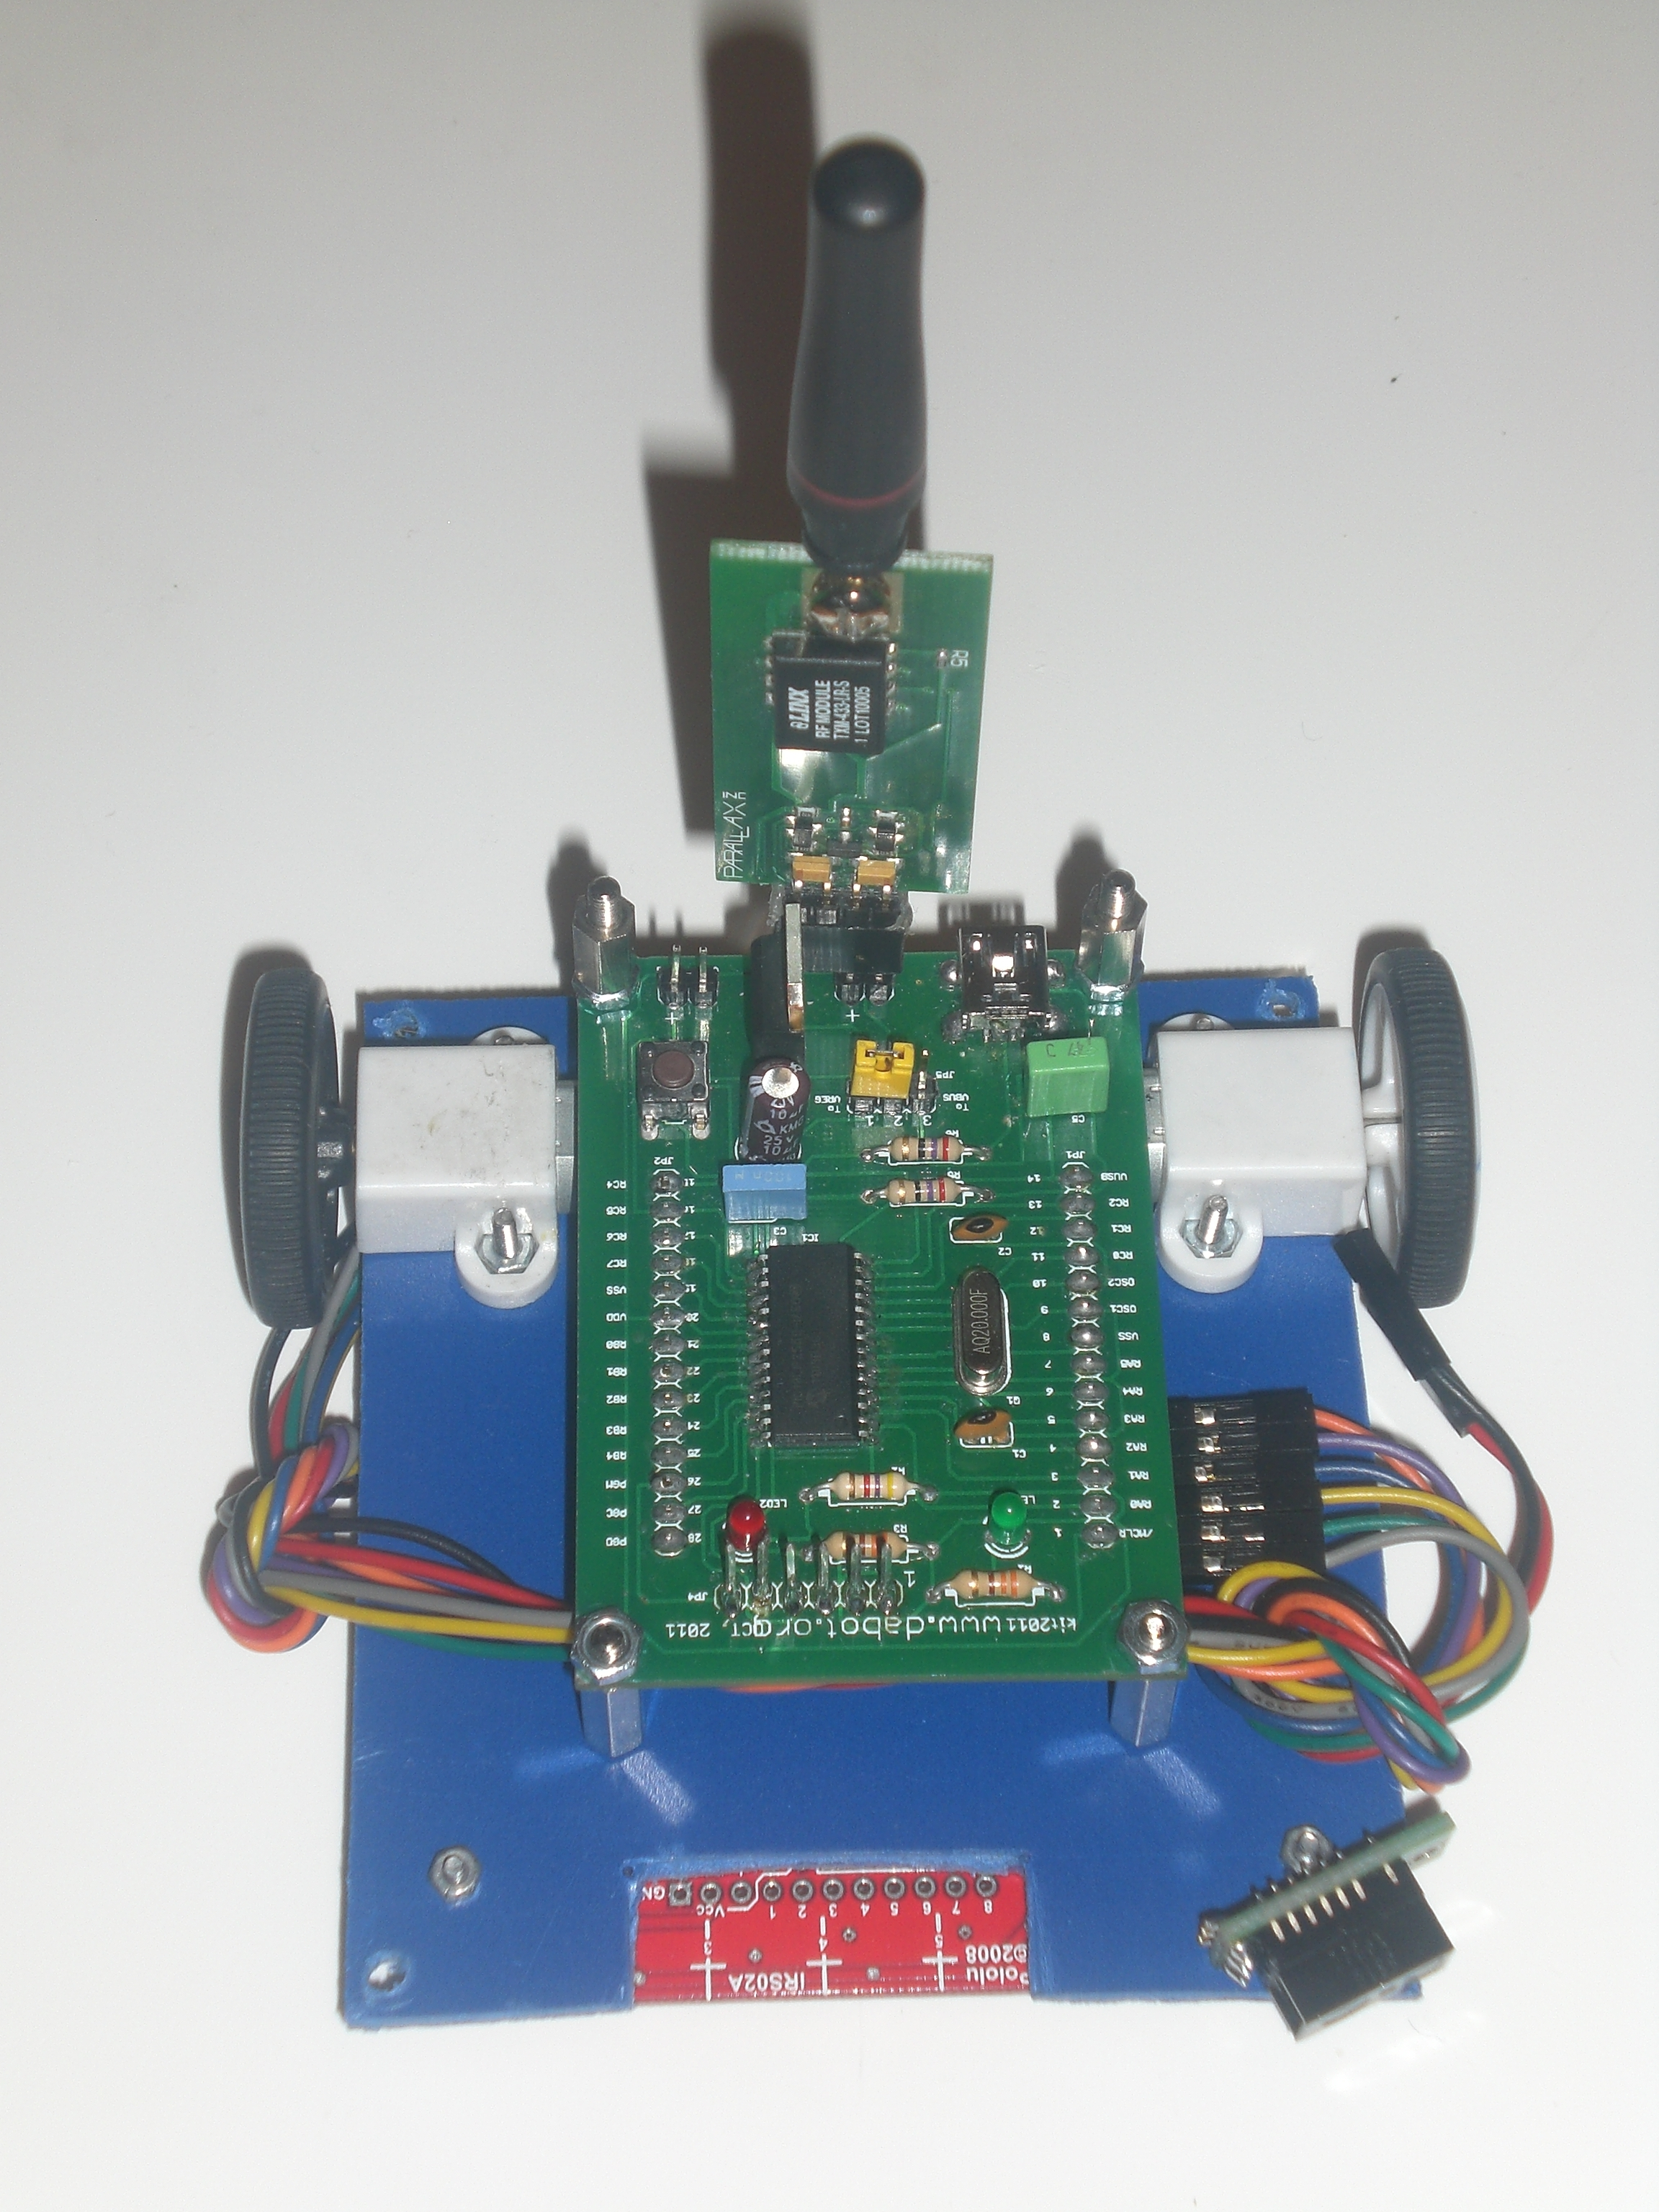

■ Working with linear actuators from Firgelli (Wow guys, the actuators are great!)
( www.firgelli.com )

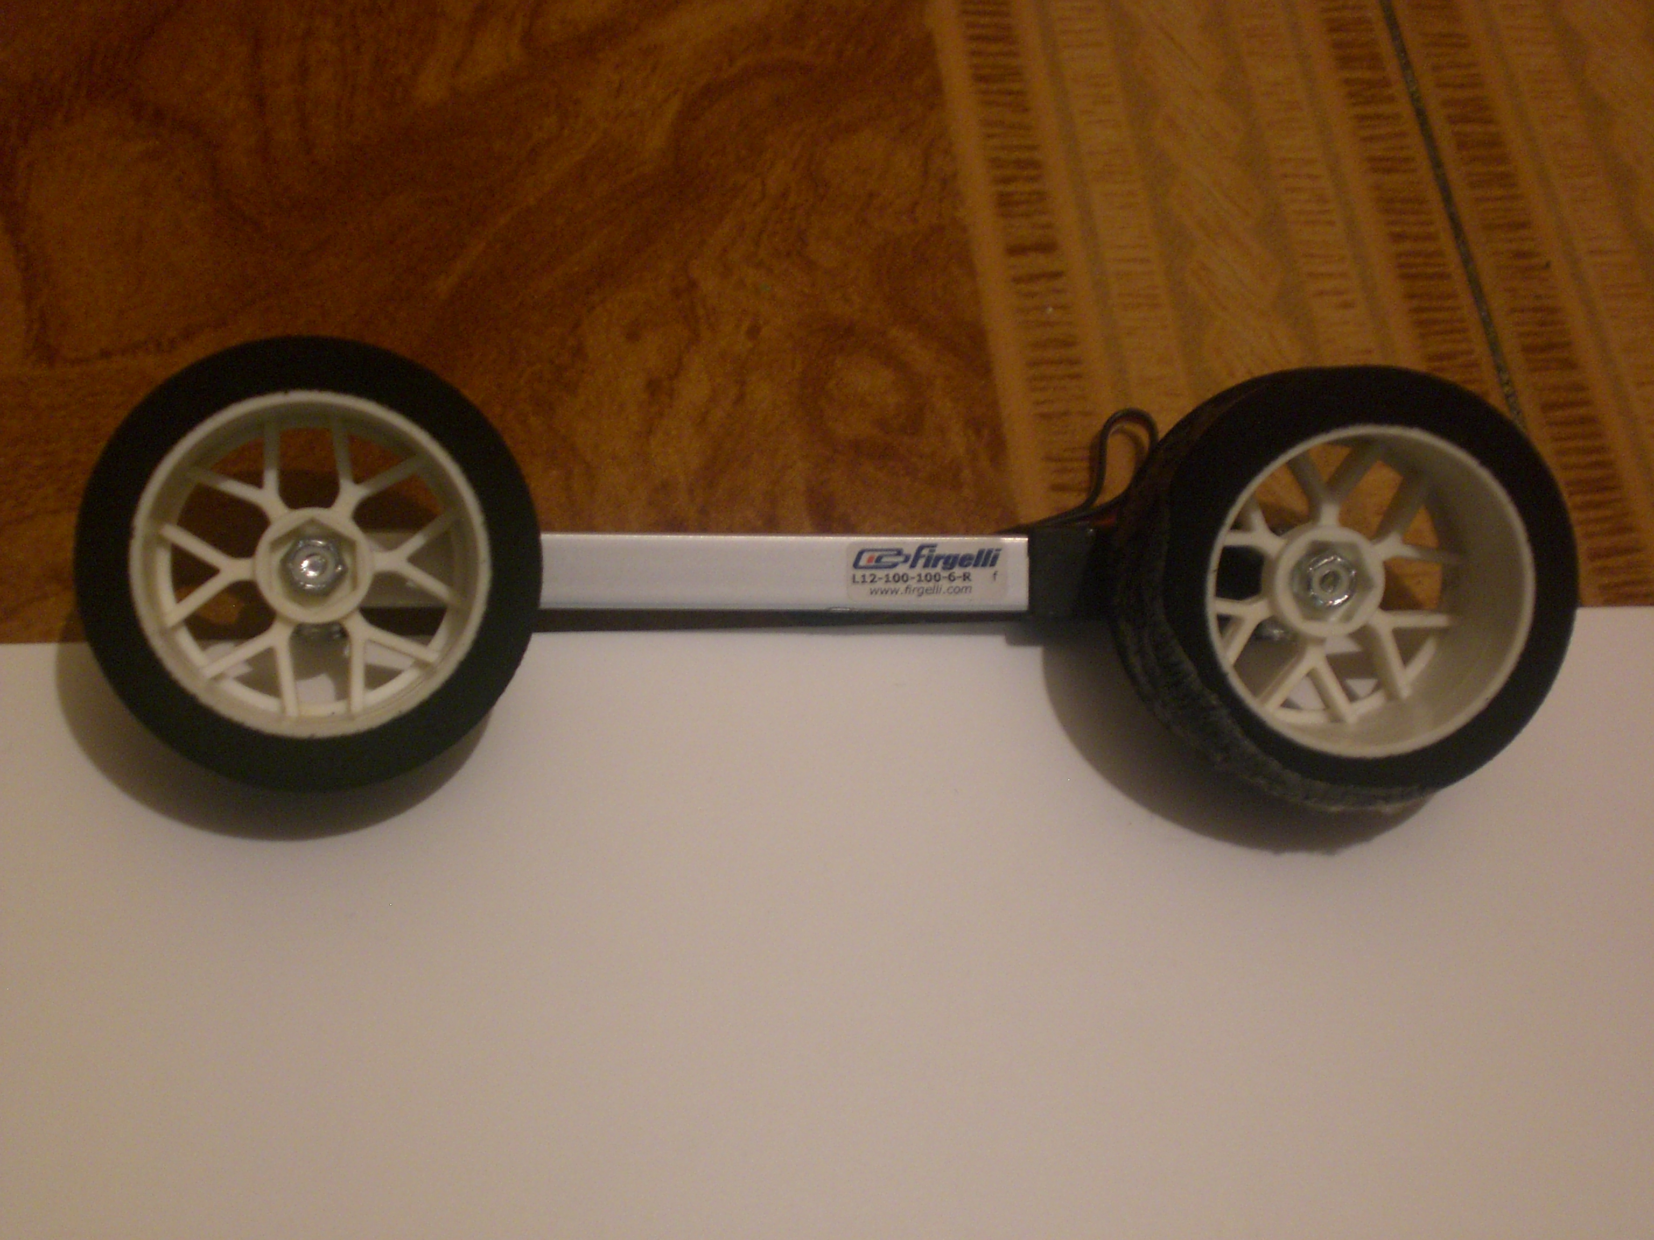

■ Cloned circuit for the replacement of the original circuit of a Back Light of a bicycle!

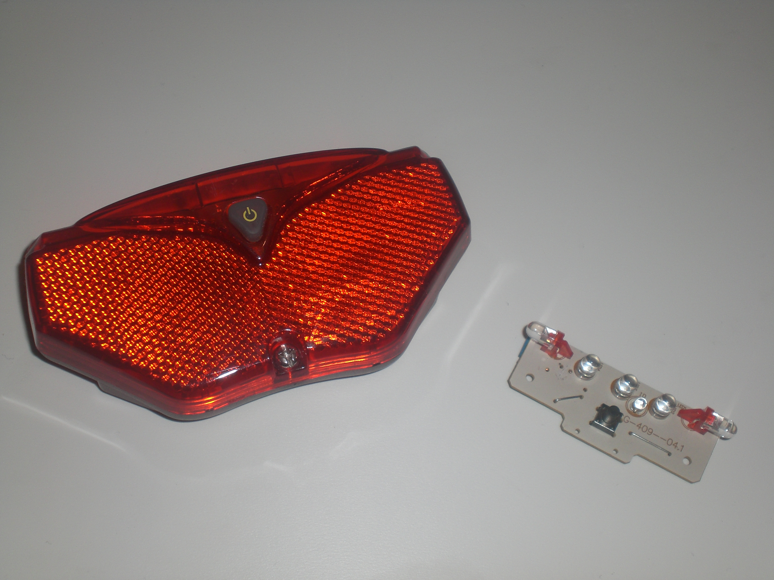

■ VFD displays + RF Zigbee + joystick + DC/DC Regulator… ready to run and really nice for the small firgers of kids! I promise it!

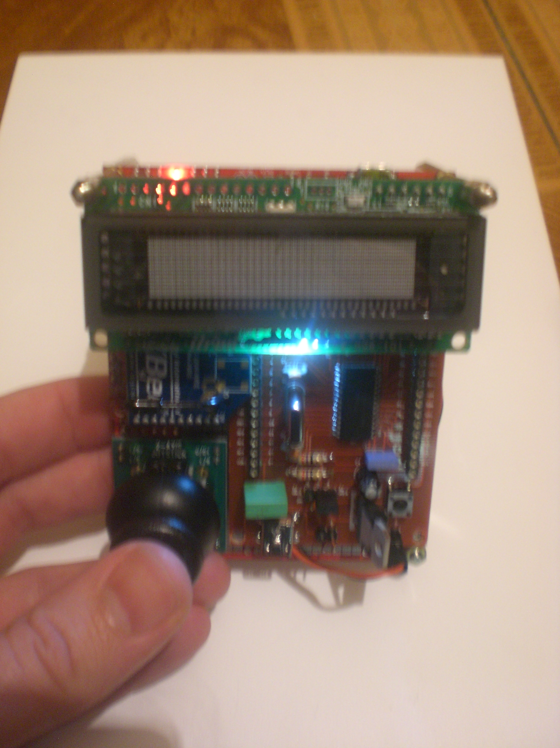

■ Radio controlled Test of a new development platform, like an assistant. It will show you information on-line, LCD TV 7”, smartphone…

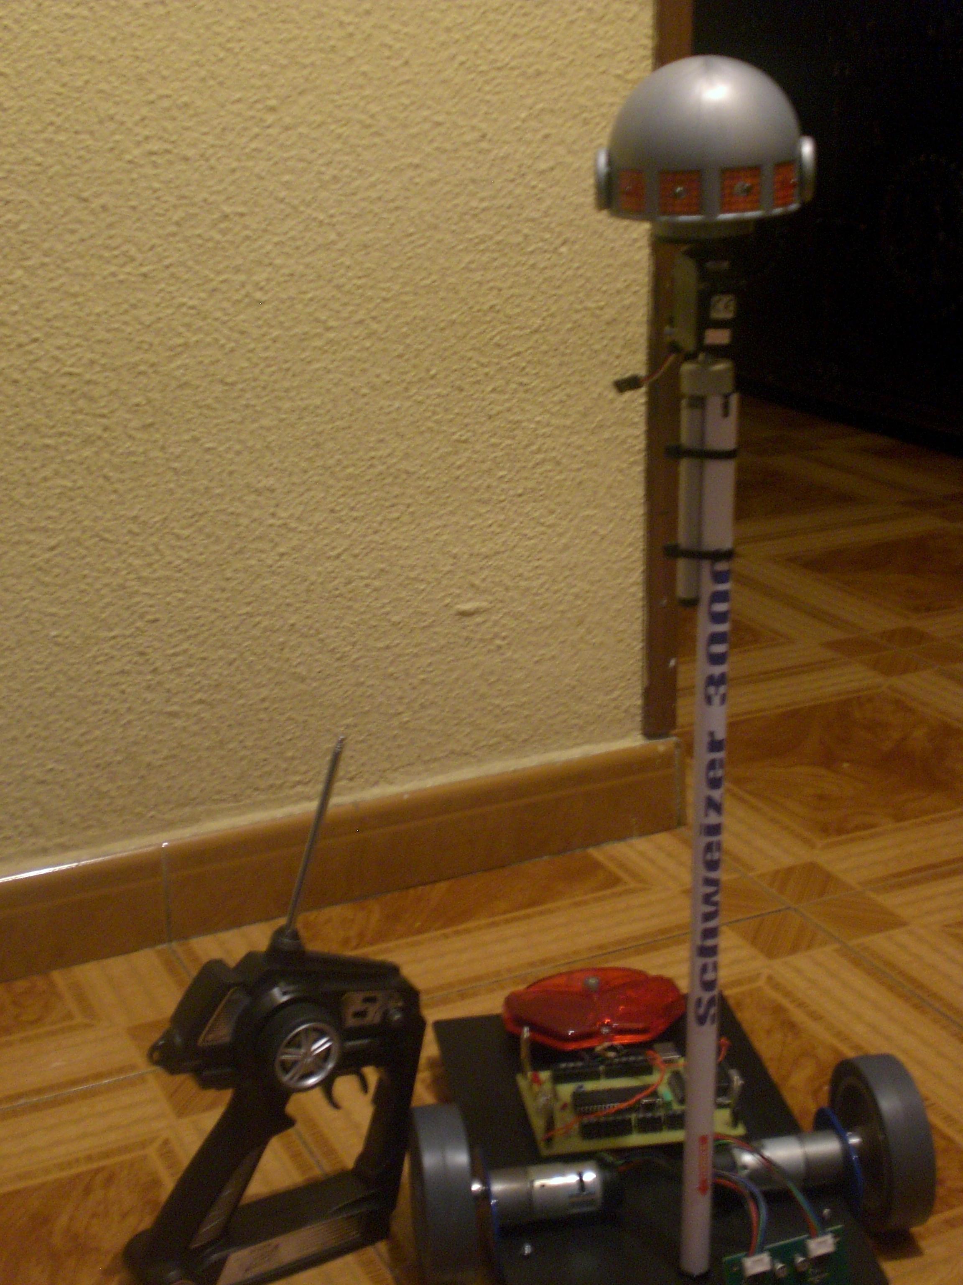
■ Geek test with GPS, tracking my movement on Google Earth, using a Long Range Bluetooth (wow, almost 1 km!)

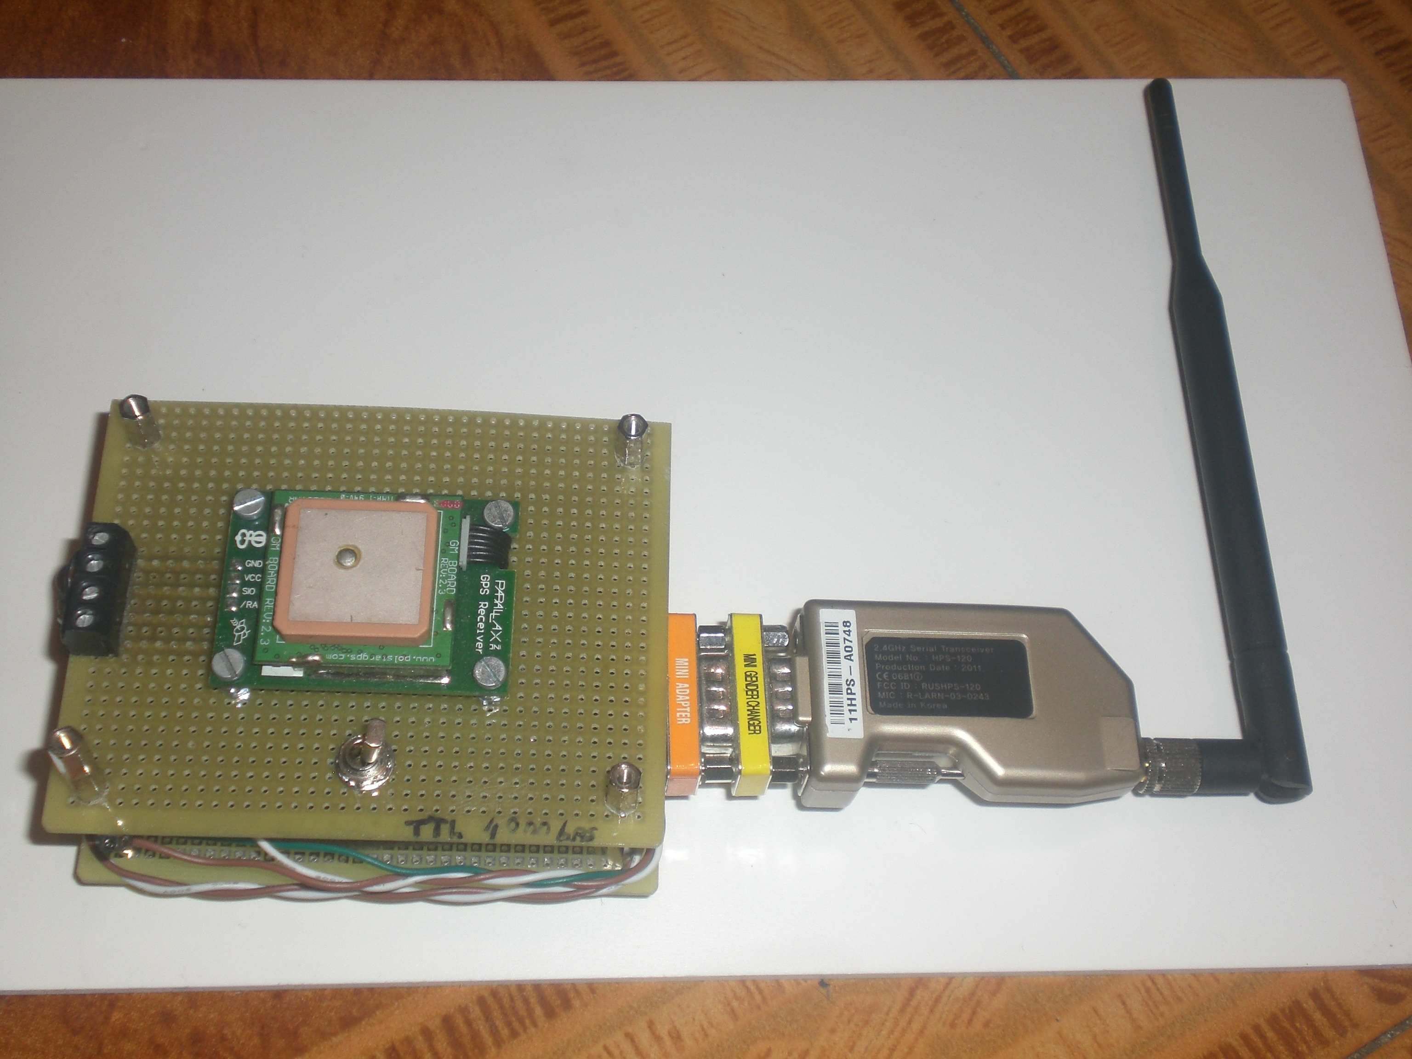

■ The new generation of a Wii stick. It is better: Gyro + Accelerometer, LiPo and really nice for control robots using the Steering Wheel, like the car of your parents!
P.S.: MarioKart is nice. Although…Luigi is the best. ;-)

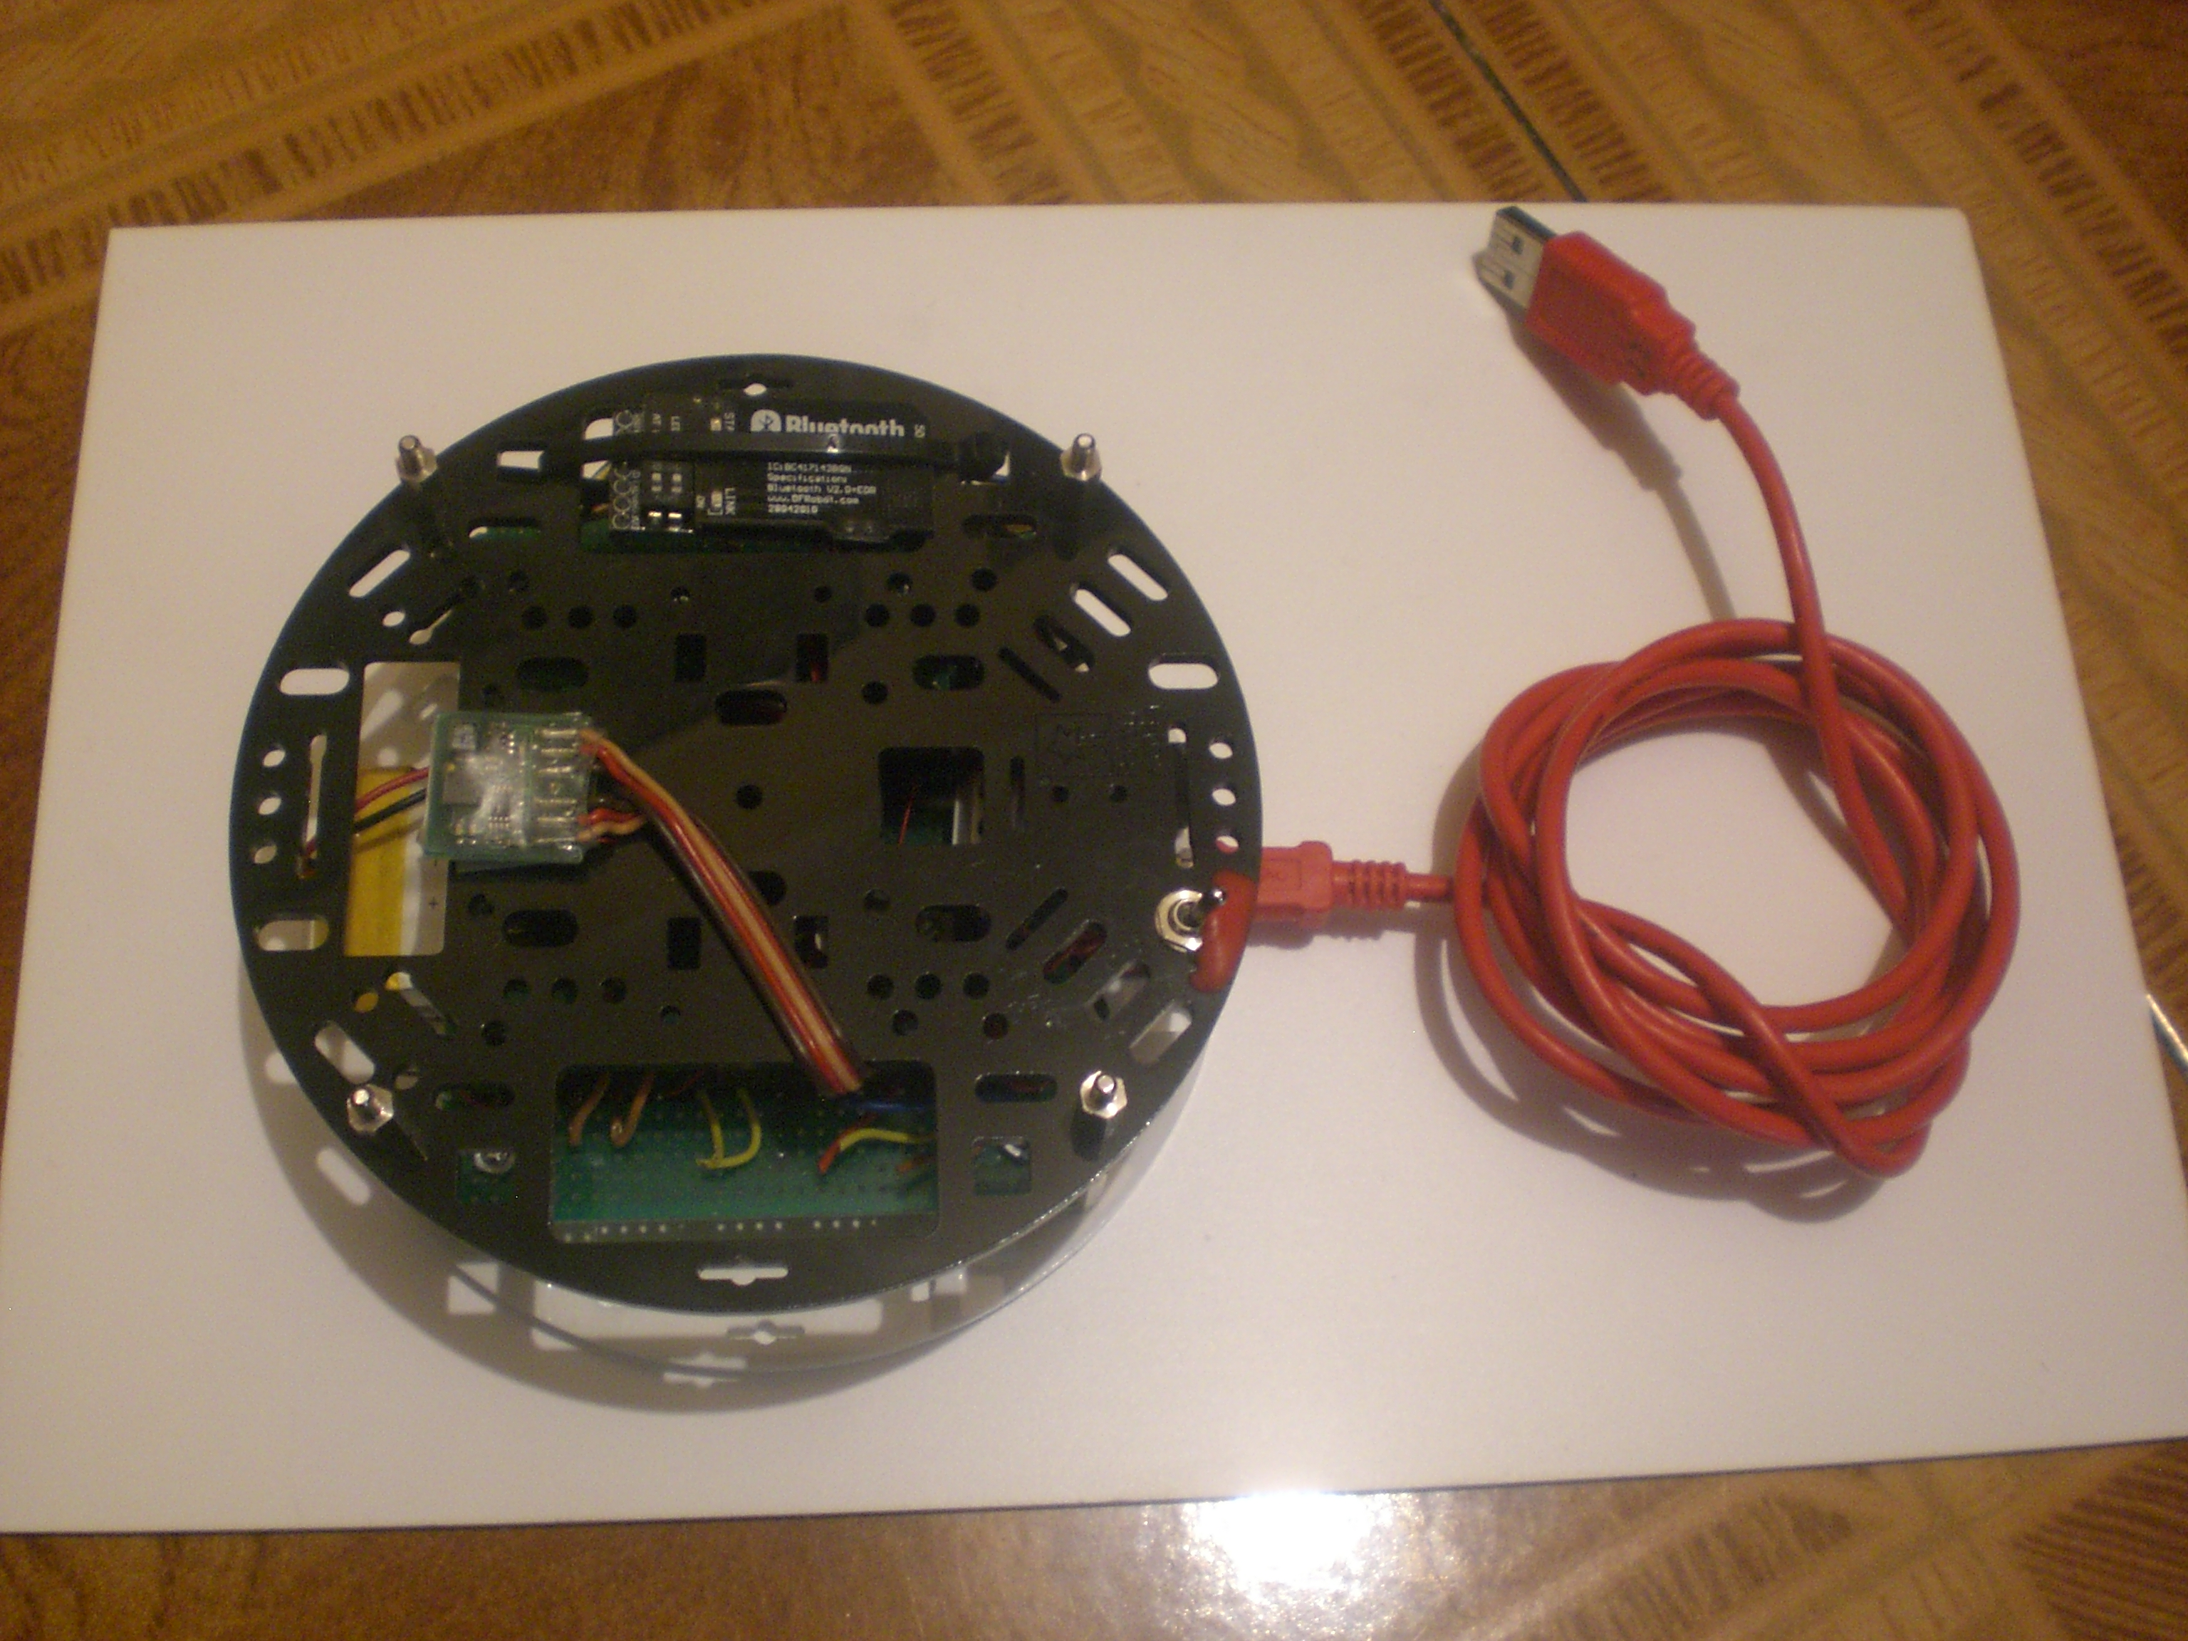

If you need more information, like…

2. - “When are you available to take up a new job?”
Right now!

3. - “Is it possible for you to give us an online overview?”
Why not?
Skype: j_m_e_m

“Also important for us to know is”
4. - “how is your life?”

Great! Because I am a Practicing Catholic man and GOD is the most import of my life.

About me: [Personal Facts, Technical Experience, Interests and Accomplishments…]

√ Like you can read, my jobs are always related with Robotics, Mechatronics, R&D, etc. because I have always worked like a polyvalent engineer.

√ I am always focused in all levels (R&D, Development of an Architecture, Design, Modelling, Simulation and Manufacturing).

√ I have a strong experience on PCB level. I am newbie on IC level (silicon level).

√ I have worked with signal processing, digital and analog architectures, PCBs design, electronic specifications for system description requirements, schematics and layouts, etc.

√ I am really responsible with development and integration of all kind of modules.

√ I enjoy interacting with other development groups and I want to understand 100% the required specifications.

√ I have collaborated with a really different work teams, because I have strong intuitive and analytical understanding of necessities.

√ I have designed and built a lot of circuits for really different fields of application like:
DC/DC Switching Regulators, Motor Drivers, LED Drivers, Interfaces for microcontrollers, Filtering for DSPs, Battery Chargers, Amplifiers, Sensing Circuits, ADCs/DACs, Software IDEs, Control Applications, Sensors and Actuators of all technologies.

Aside from that, more things about me are:
Experience in Innovative Program Development and Handling of High Speed Trains.

Ability to demonstrate leadership skills and motivate people towards research goals by means through effective and organizing and resourcefulness.

Skilled and passionate about educating and motivating others.

Experienced Professor, capable of effectively interacting with people of various ages, religious and cultural backgrounds.

Competitor in Robotic Events around the World.

Lover of animals and babies! and Dog Breeding.

Lead Mentor of the 1st FRC Spanish Team #4278 (www.usfirst.org)

Dedicated to the Practice and Implementation of Catholic Faith.
Being a dedicated member of a large close knit family.

Thank you very much.
Please, feel free to contact me.

Best regards.

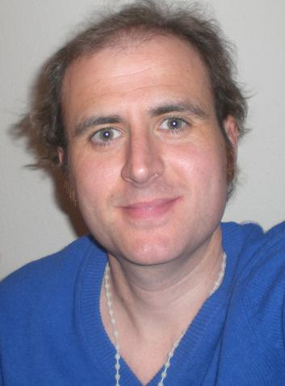
José Magro Espinosa de los Monteros
Webpage: www.dabot.org
Channel: www.youtube.com/user/josemonteros
E-mail: j_m_e_m@yahoo.es
Skype: j_m_e_m

